|  |  |
| --- | --- |
| **Project title** | **Gala Lunch – Restaurant site** |
| **Author(s)** | **Bucur Alexandra , Chereji Iulia** |
| **Group** | **30424** |

# Task Description

The application will handle orders from customers. They will be able to order several types of food (pizza/pasta/salads etc.) from a menu. The application has a cart that will store all the desired/selected items until the checkout is done.

At the checkout the user will be able to choose between “Home delivery” and “Pick-Up”; in other words to choose how the food will get to the customer. For the pick-up there will also be a choice of location (user can choose from several locations of the restaurant). The user will be able to choose the payment method (cash/card).

The application will also have the possibility to create accounts for customers. So the customers can create new accounts or log in into already existing accounts. For the created accounts the information about address and phone will be hold so the user doesn’t have to input them every time he/she places an order. Also, every user will be able to modify its personal information at any time. The application will allow placing orders for the customers with no account as well. The advantage for the user account is that the order may be placed faster and there can be some bonuses/discounts.

The user interacts with the application through several buttons available on the screen (by clicking on them) and by writing in some data regarding personal information (input the address/name/surname etc.).

* 1. **Detailed specification/ functioning of the application**

At first the application will show the main page, which is also the home page, from this, the user will be able to go to the “LogIn” page and introduce his/her account or start directly ordering whatever he/she needs. By clicking on the buttons that have several names of types of food on it, the customer will be taken to the page corresponding to the type of food that was chosen.

On the “FoodType” page, the user will be able to see all the available dishes that the restaurant can provide. Each type of food will have a description about the ingredients that are used, a price and a photo. By clicking once on the photo, that selected course will be automatically inserted in the cart. If the user would like more than one portion of a certain dish, he/she should click on the afferent photo as many times as the number of desired portions.

By clicking the home button that is on the top-left corner on each page, the user will be able to go back to the main page and decide what to do next – choose another type of food, login or see cart in order to check out.

Another button that can be seen on all pages is the login button. So whenever the user wants to connect to his/her account, by clicking on that button, he/she will be able to do so. At the login page the user should introduce an email corresponding to the account from the database and the afferent password. Until the password and email correspond to the ones that are in the database, the user will be not able to connect. After connecting, the customer will be able to see that his/her name can be seen on top of the page, on the right corner. By clicking on the name, the customer will be able to see all the details related to the account such as name, date of birth, address, phone number and so on. All the information can be changed or updated if the user wants to. Such a situation might happen when the customer changes his/her phone number. Moreover, if the customer wants to, he/she can log out from the account from that page, by simply clicking on the

“Log Out” button. The user will be taken to the “Home” page and decide what to do next.

If the user has no account and decides to create one, by clicking on the login button, on that page, there is also another button for creating an account. The customer will now see another page, the “SignUp” page. On that page, the user will have to introduce several personal data, such as name, phone number, but also an email and password that will be used when connecting to the account in the future. If the email introduced is already used, there will be a special message that will appear on the screen on order to warn the user about the faulty email. Not all fields are mandatory, only those which are marked with a “*”. By not completing them, the customer will not be able to create the account. After all information was completing as requested, the customer will be able to create its account by clicking once on the “Create account” button. After this the customer will have an active account and will be automatically be logged in during the current session (until the application is closed) or until the customer decides to log out. The information about the account will be stored in a database.

One more button that can be seen on all pages is the “cart” button, which is on top-right corner of the page. By clicking on it, the customer will be taken on the “Cart” page. At the beginning the cart will be empty, since no item was inserted in the cart. As the customer inserts things in the cart, they will also appear on that page. The customer will be able to see a photo of the dish he ordered, name of the dish and the number of portions (quantity). For each of the items in the cart, there will be available 2 buttons (“+” ;“-”) that will increase/decrease the number of portions for the selected item. If only one item is in the cart and the “-” button is pressed, the item will disappear from the cart. At each step the price is updated according to the customer’s action. So there can be seen an intermediary price for each item and on the bottom of the page, the total price.

After the customer decides that the cart is in its final form and all desired items are inserted, by clicking on the “Checkout” button, another page will be seen, more exactly the “Checkout” page, which is the last page of the project. On this page, the user will be able to insert the address where the items will be delivered. If the customers want to pick the food from the restaurant, there is an option to do so. So, in that case, the “Pickup” option should be selected and the address field left blank. There is one more option, which is the one related to the payment method. The customer has the ability to select between cash or card payment, by clicking on the desired checkbox. At the end, the customer will place the order by clicking on the afferent button.

* 1. **Further development**

The application can be further developed. We thought of inserting a map in order to see the location of the restaurant/s (if there are several locations). The application can also have a tracking page, where the customer can see where their order is and the duration left until the order will arrive to the destination.

Another interesting idea would be to implement discounts/ surprises for the customers. Discounts for certain types of food, for example “All burgers are 10% off on Friday”. And surprises for customers that place orders on their birthday, for example to have 15% off.

One of the most important further implementation would be to make this application a web application in order to make it more accessible. In this way all customers will be able to access the menu of the restaurant more easily, without having to download the app.

* 1. **GUI**
     1. The Main Page

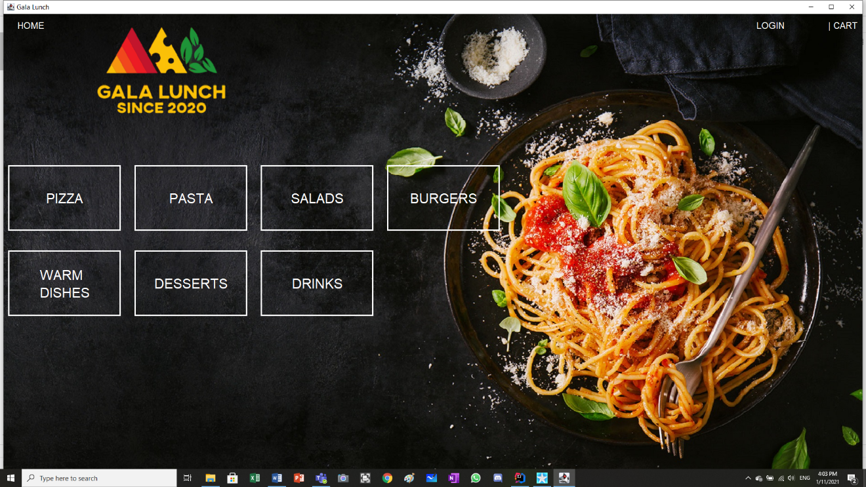

* + 1. The Type-Of-Food Menu Page

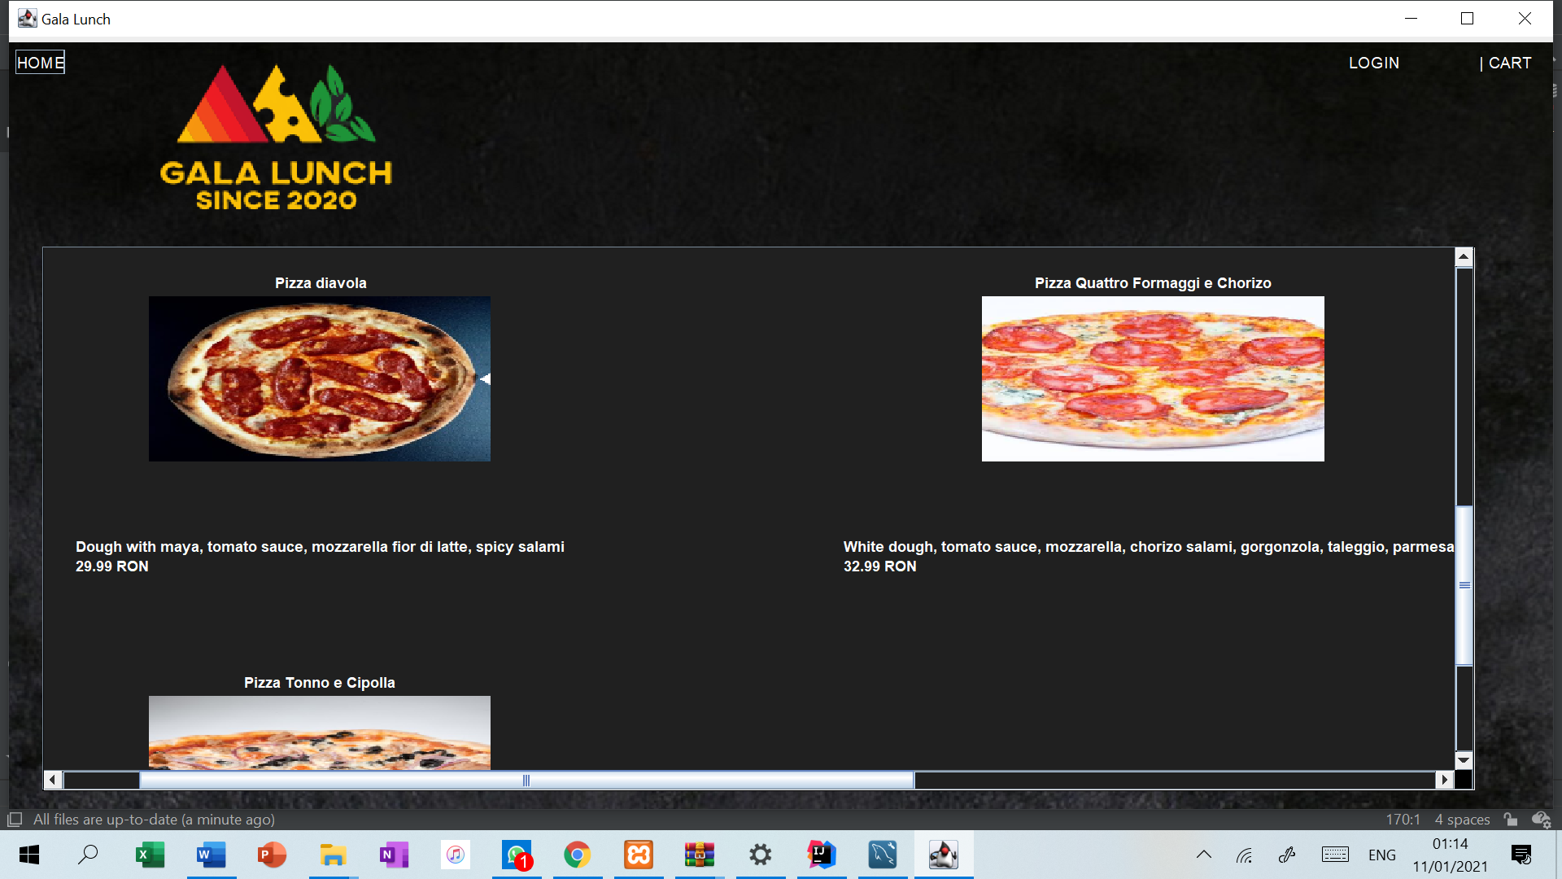

* + 1. The Log In Page

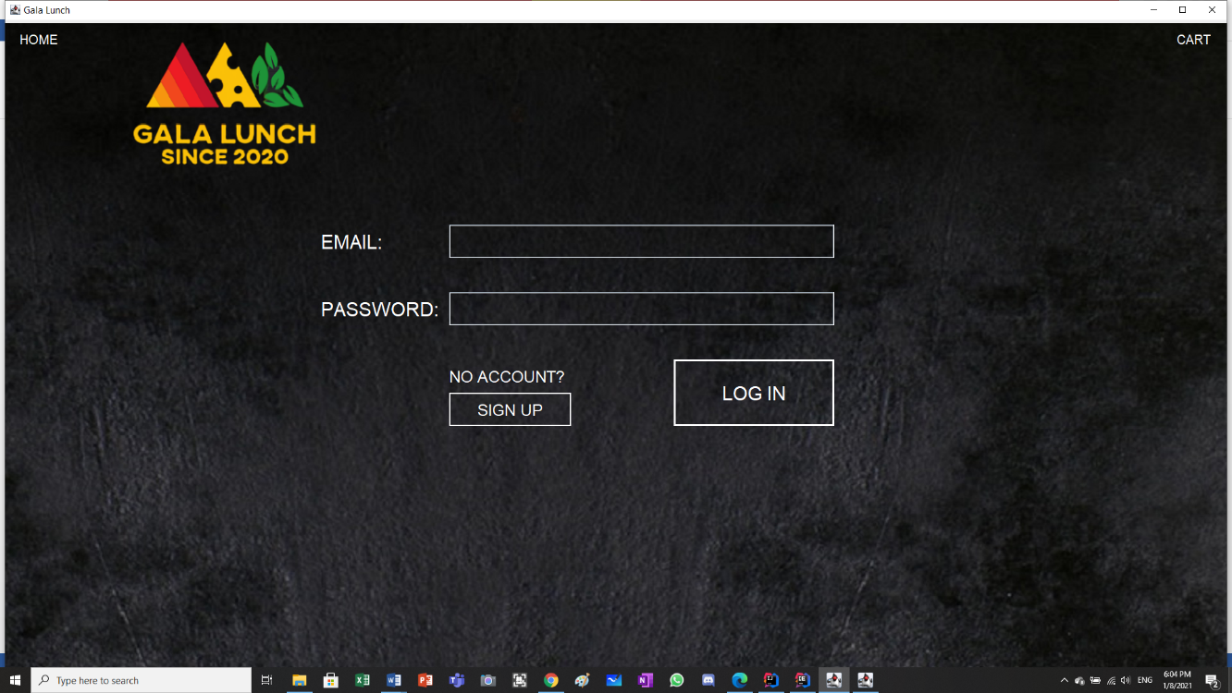

* + 1. The Sign Up Page

1.1.5 The User Account Page

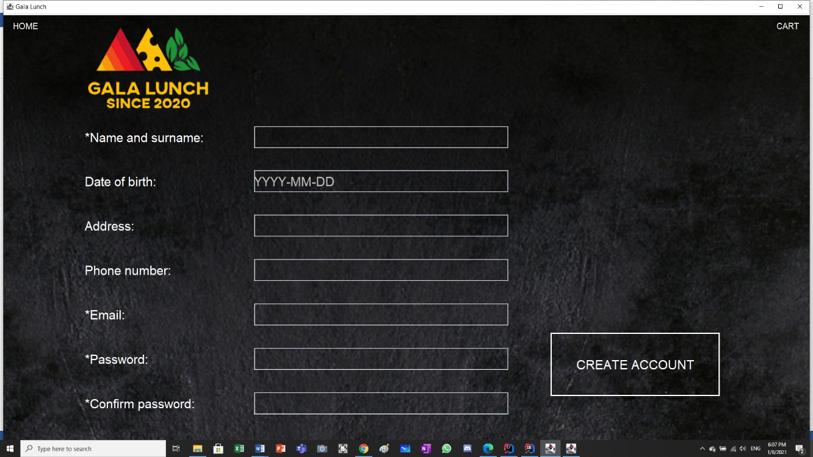

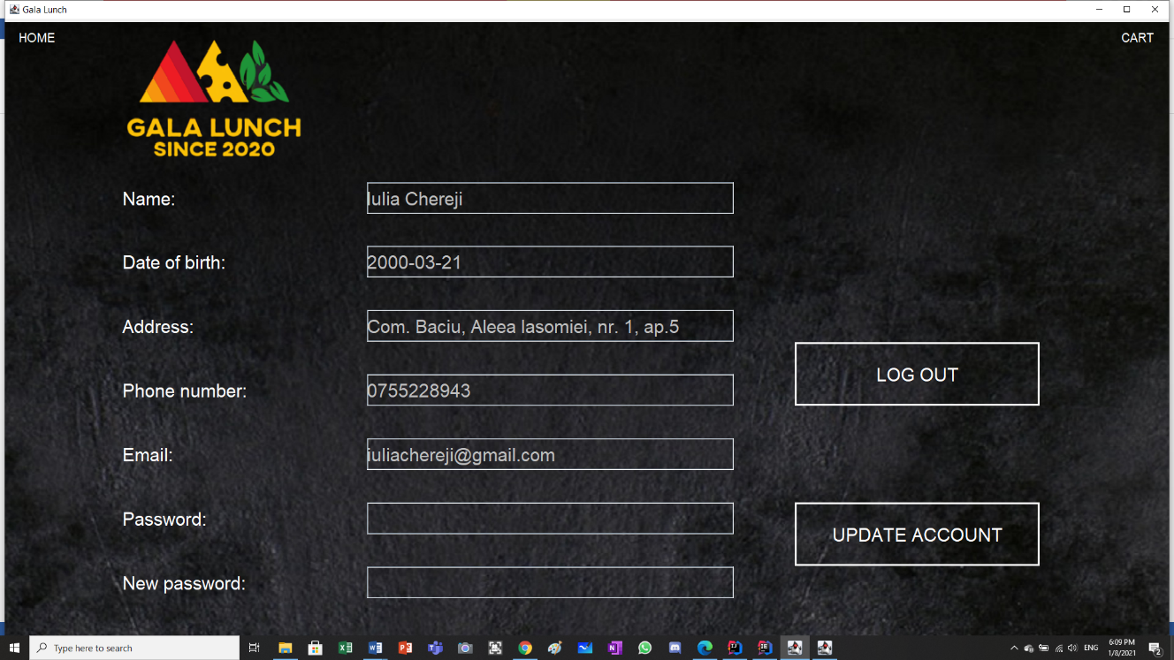

* + 1. The Cart Page

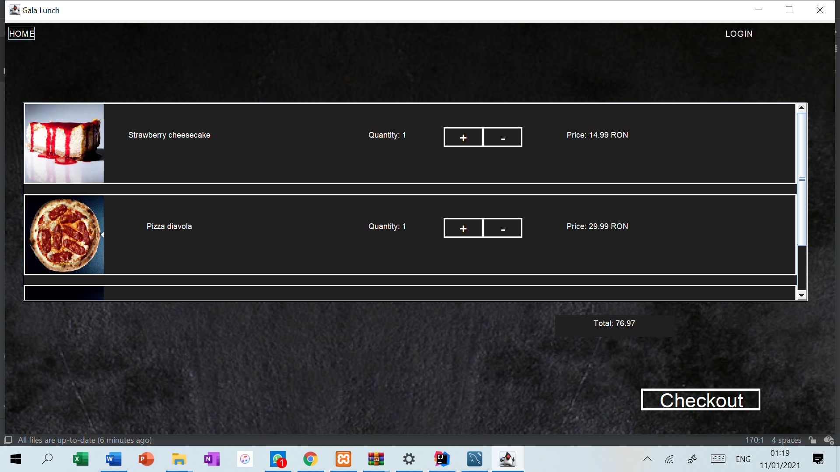

* + 1. The Order Options Page

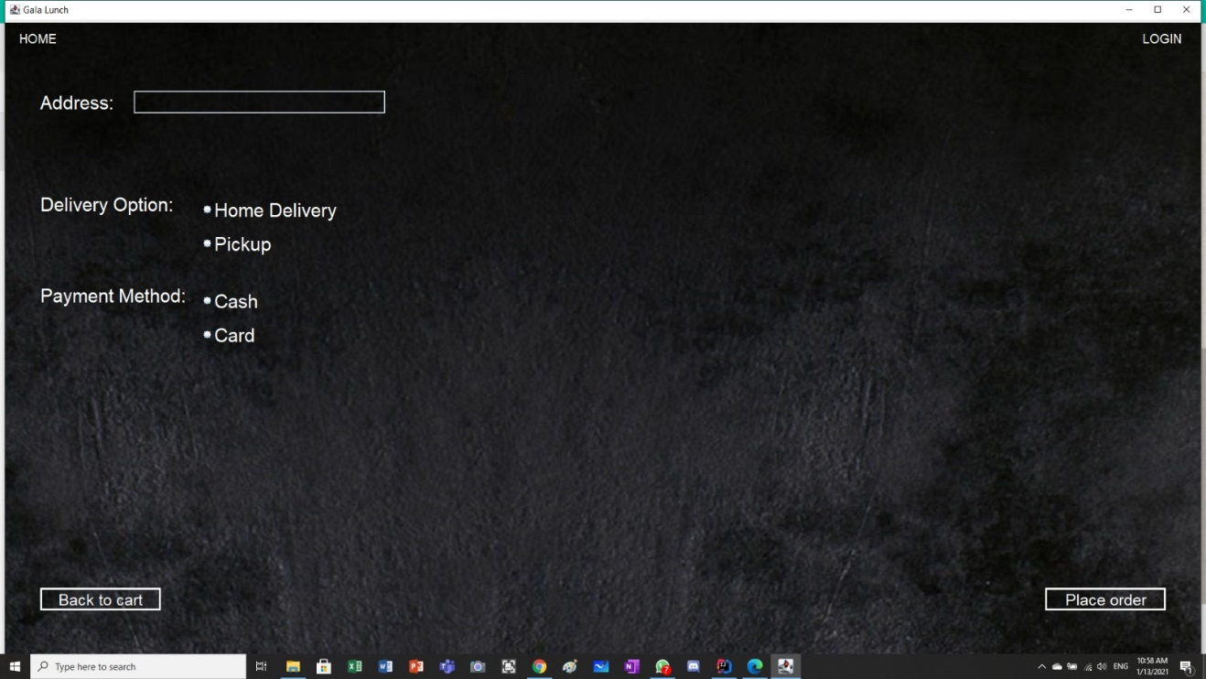

1. **Class Discovery**
   1. **Class Responsibility Collaborations Cards**

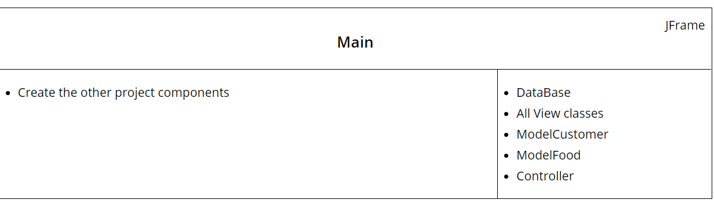

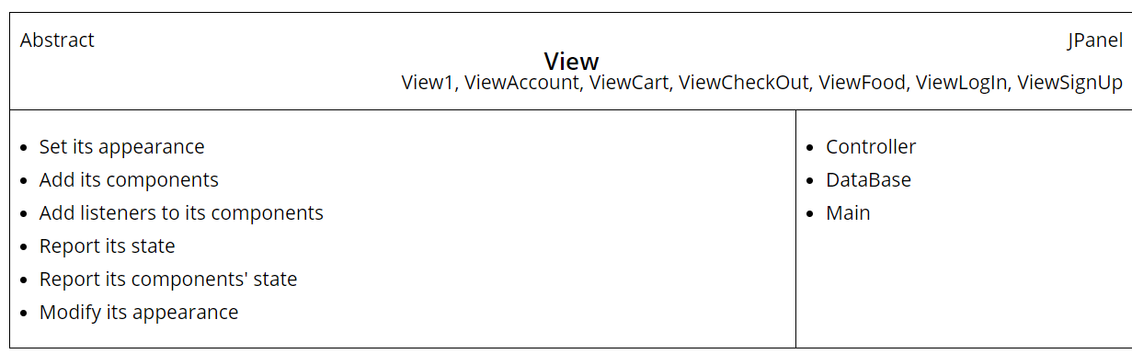

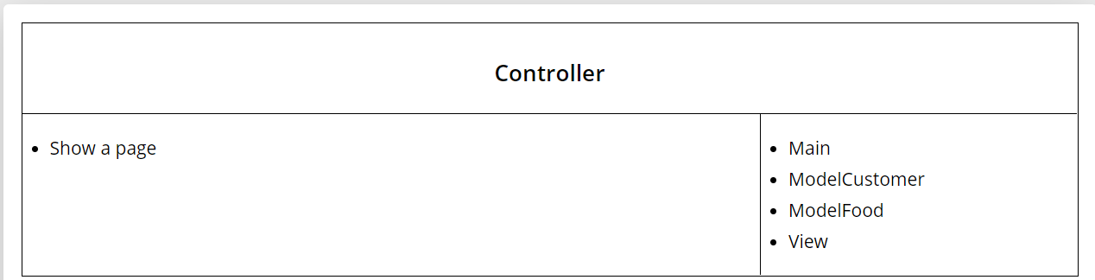

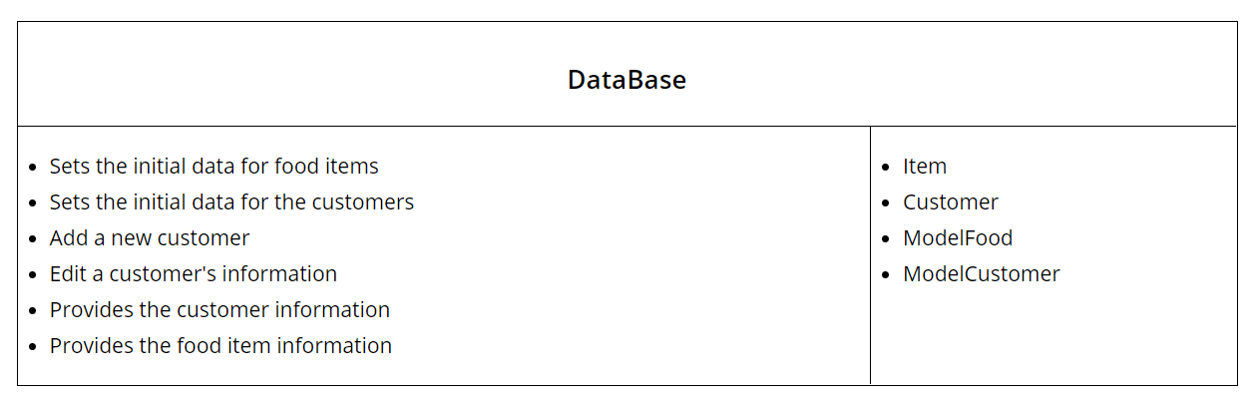

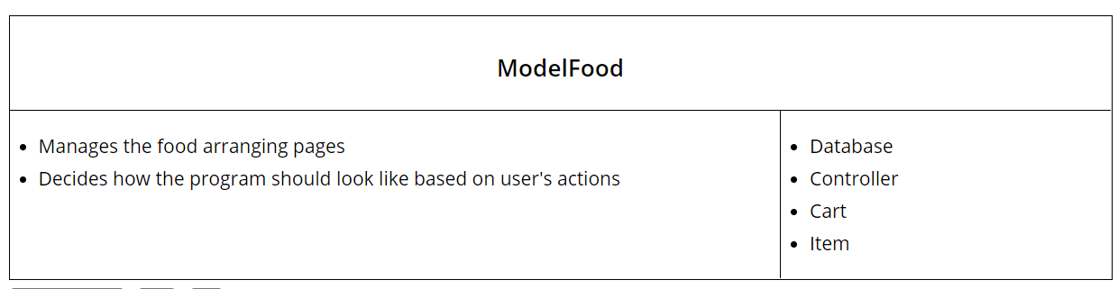

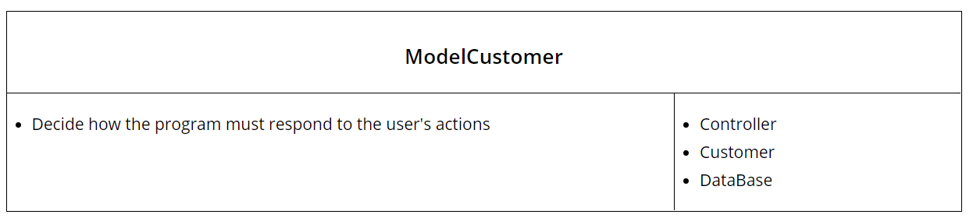

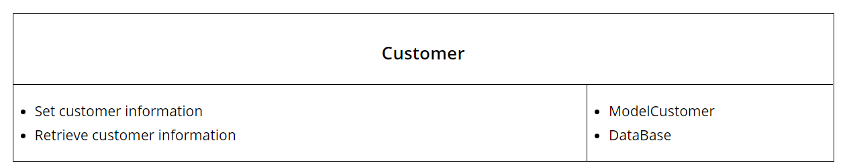

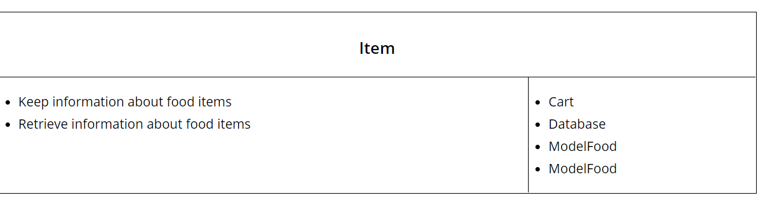

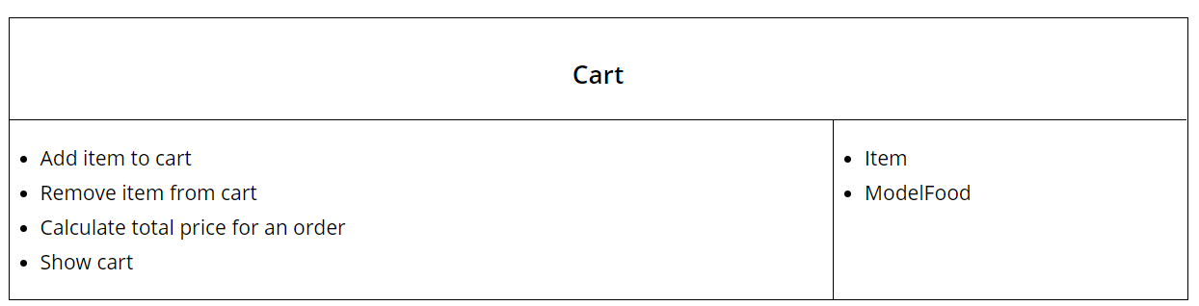

**2.2 Class Diagram**

